Social Media Kit

Hashtags:
#PrivateEdPrinciples
#AbidjanPrinciples

Others:
#GuidingPrinciples
#Education
#HumanRights

Social media handles of coordinating organisations:
Organisation | Twitter | Facebook
NORRAG | @norrag | norrag.network
Right to Education Initiative | @RTEInitiative | RTEInitiative
Amnesty International | @Amnestypress
Equal Education Law Centre | @EElawcentre | EqualEducationLawCentre
Global Initiative for Economic, Social and Cultural Rights | @GIESCR | GIESCR
Initiative for Social and Economic Rights | @ISERUganda | ISERUganda
Open Society Foundation | @OSFEducation

Website: www.abidjanprinciples.org

Sample Tweets
Choose images and videos from the following link: www.abidjanprinciples.org/media

Upcoming Conference:

One week to Abidjan Adoption Conference on the role of the State and private actors in education. #AbidjanPrinciples #PrivateEdPrinciples Learn more www.abidjanprinciples.org

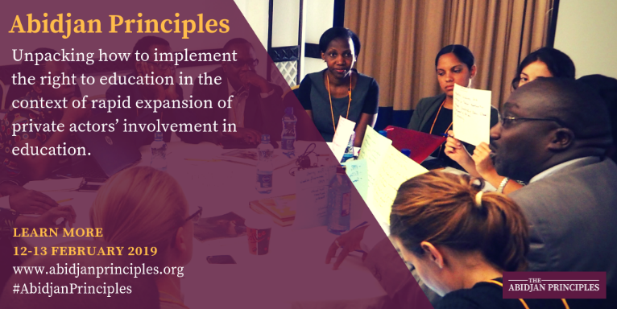
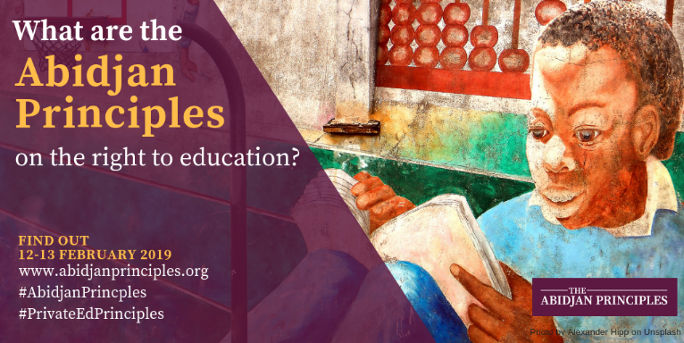

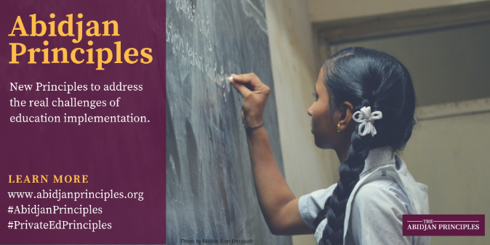
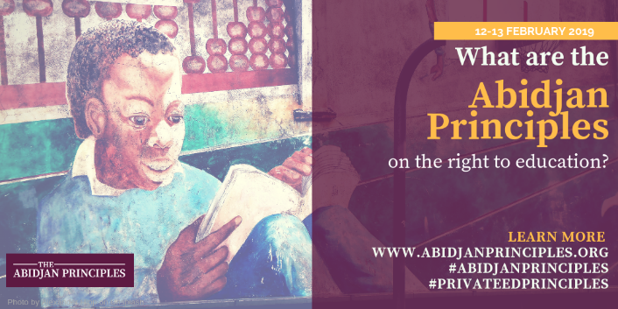
Landmark text gives reference point to assess the role of the State and private actors in education. #AbidjanPrinciples #PrivateEdPrinciples Learn more www.abidjanprinciples.org

With the rise of private actors in #education how do States effectively implement the right to education? Follow #AbidjanPrinciples #PrivateEdPrinciples to learn more www.abidjanprinciples.org
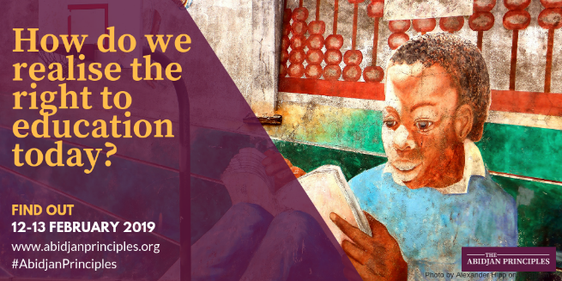
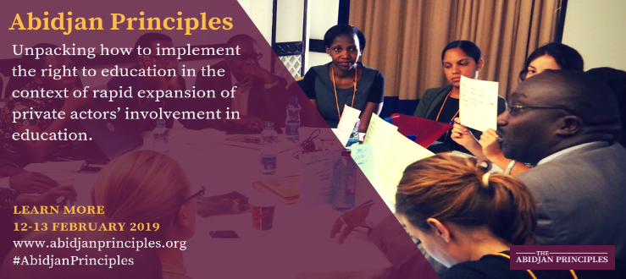

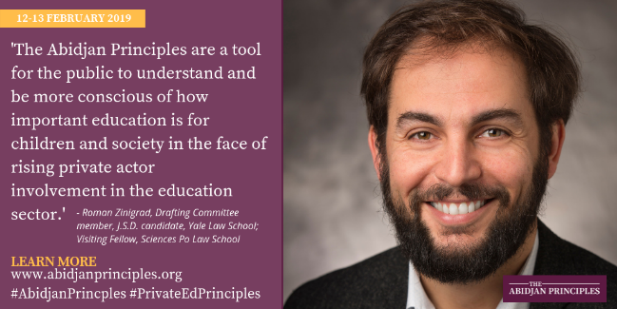
#HumanRights and #Education experts set to adopt the Abidjan Principles on the Right to #Education. Learn more www.abidjanprinciples.org #AbidjanPrinciples #PrivateEdPrinciples
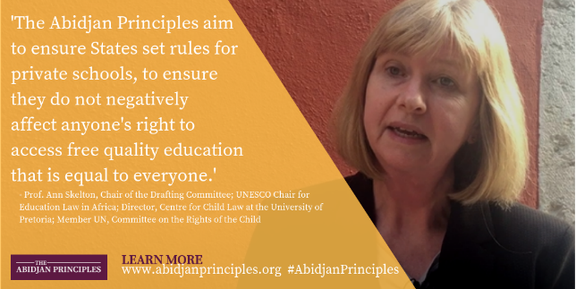

Education & #HumanRights experts will meet for the Abidjan Adoption Conference on the right to #education. Learn more www.abidjanprinciples.org #AbidjanPrinciples #PrivateEdPrinciples

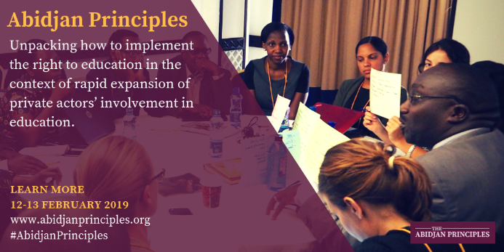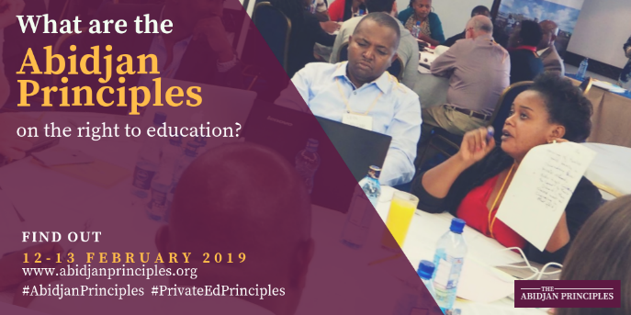

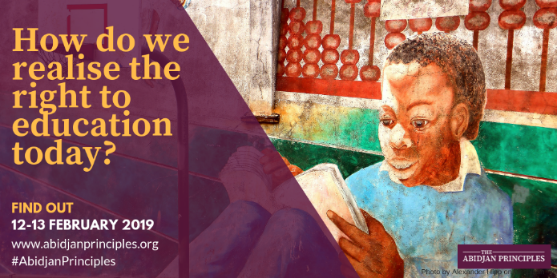
Rapid expansion of private actors involved in #education new human rights guiding principles to be adopted. Learn more www.abidjanprinciples.org #AbidjanPrinciples #PrivateEdPrinciples #Education
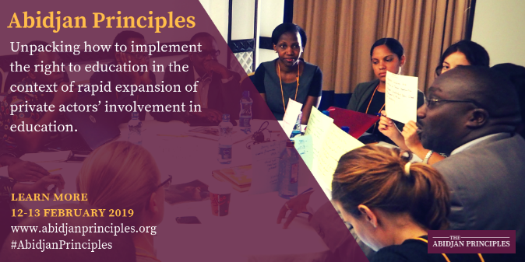

#AbidjanPrinciples on State obligations related to private actor involvement in #Education are set to be adopted by experts this month. Learn more www.abidjanprinciples.org #PrivateEdPrinciples

- Video of Ann Skelton: https://www.youtube.com/watch?v=PWv8pUZxcPs
- Video of Roman Zinigrad: https://www.youtube.com/watch?v=wDRvCSW9Kpk
- Video of Salima Namusobya: https://www.youtube.com/watch?v=fQaK3MrXgXQ

Adoption

Today: #Human Rights #GuidingPrinciples on State obligations related to private actor involvement in #Education adopted. #AbidjanPrinciples #PrivateEdPrinciples Learn more www.abidjanprinciples.org
[insert image/video]
Adoption of new Human Rights #GuidingPrinciples on State obligations related to private actor involvement in #Education. #AbidjanPrinciples #PrivateEdPrinciples Read more www.abidjanprinciples.org
[insert image/video]

New Guiding Principles unpack how to implement the right to #education in the context of rapid expansion of private actor involvement in education. Learn more www.abidjanprinciples.org #AbidjanPrinciples #PrivateEdPrinciples [insert image/video]

New tool for the implementation & regulation of the right to #education adopted by global education & human rights experts. Learn more www.abidjanprinciples.org #AbidjanPrinciples #PrivateEdPrinciples [insert image/video]

New tool adopted to ensure accountability in the provision of education. Learn more www.abidjanprinciples.org #AbidjanPrinciples #PrivateEdPrinciples #Education [insert image/video]

New Guiding Principles offer guidance for governments trying to navigate the myriad of private actors in education systems. Learn more www.abidjanprinciples.org #AbidjanPrinciples #PrivateEdPrinciples #Education [insert image/video]

Sample Facebook posts
Choose images and videos from the following link: www.abidjanprinciples.org/media

Upcoming Conference:

What is the right to education? #AbidjanPrinciples #PrivateEdPrinciples Learn more www.abidjanprinciples.org

- Video of Salima Namusobya: https://www.youtube.com/watch?v=BeedGIn9mH4
- Video of Roman Zinigard: https://www.youtube.com/watch?v=VUY97ZPWORk
- Video of Ann Skelton: https://www.youtube.com/watch?v=oTZb2h1i6ek

What are the Abidjan Principles on the right to education? Landmark text promises to be the new reference point for the discussion on the role of the State and private actors in #education Learn more www.abidjanprinciples.org #AbidjanPrinciples #PrivateEdPrinciples

- Video of Ann Skelton: https://www.youtube.com/watch?v=PWv8pUZxcPs
- Video of Roman Zinigrad: https://www.youtube.com/watch?v=wDRvCSW9Kpk
- Video of Salima Namusobya: https://www.youtube.com/watch?v=fQaK3MrXgXQ

Education & #HumanRights experts will meet for the Abidjan Adoption Conference on the right to #education. Learn more www.abidjanprinciples.org #AbidjanPrinciples #PrivateEdPrinciples
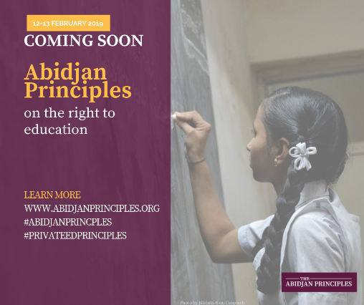
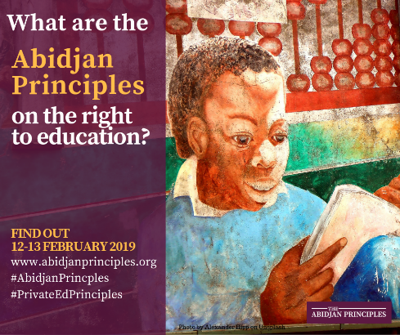

Rapid expansion of private actors involved in #education new human rights guiding principles to be adopted. Learn more www.abidjanprinciples.org #AbidjanPrinciples #PrivateEdPrinciples #Education

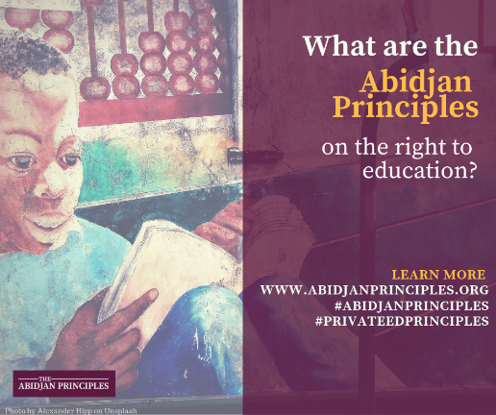
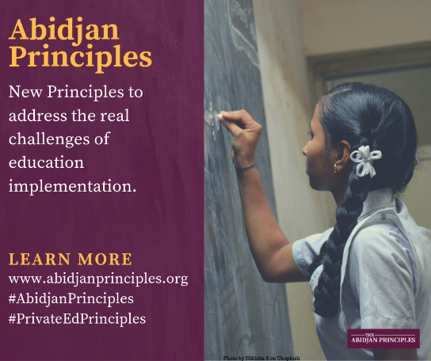

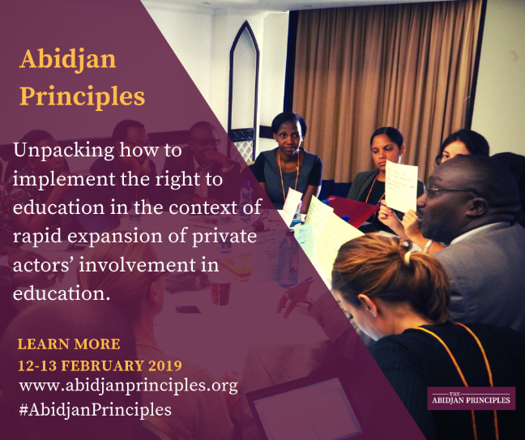
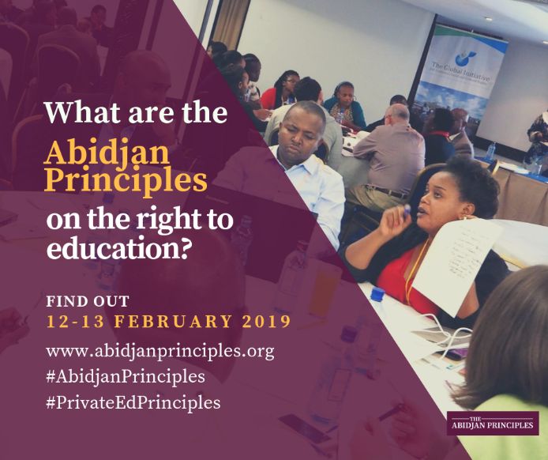
#AbidjanPrinciples on State obligations related to private actor involvement in #Education are set to be adopted by experts this month. Learn more www.abidjanprinciples.org #PrivateEdPrinciples

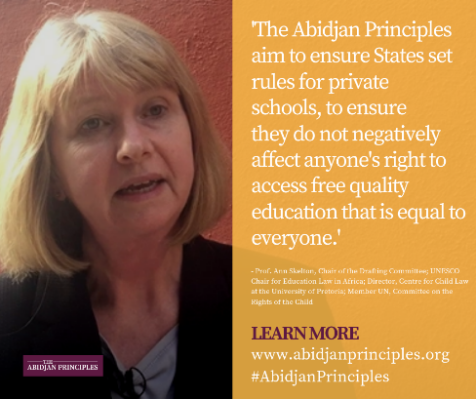
Education & #HumanRights experts will meet for the Abidjan Adoption Conference on the right to #education. Learn more www.abidjanprinciples.org #AbidjanPrinciples #PrivateEdPrinciples

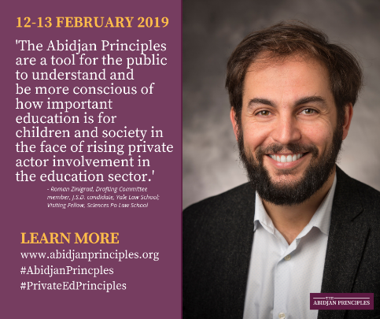

Launch:

We are excited to announce the adoption of the Abidjan Principles today, by global experts in international human rights law and education. These Principles bring clarity on existing legal obligations of States regarding the implementation of the right to education. Learn more www.abidjanprinciples.org #AbidjanPrinciples #PrivateEdPrinciples [insert image/video]

Drawing on existing #HumanRights standards, the Abidjan Principles compile and clarify States’ existing obligations as it relates to State delivery of education and the role and limitations of delivery by private actors. Learn more www.abidjanprinciples.org #AbidjanPrinciples #PrivateEdPrinciples #Education [insert image/video]

New Principles to ensure greater accountability for the right to education launched today. The Human rights guiding principles on states’ obligations regarding private actors, also known as the Abidjan Principles, were adopted by a group of global human rights and education experts. Learn more www.abidjanprinciples.org #AbidjanPrinciples #PrivateEdPrinciples #Education [insert image/video]

Guiding Principles adopted by global human rights and education experts to bring clarity and guidance to the implementation of the right to education. Learn more www.abidjanprinciples.org #AbidjanPrinciples #PrivateEdPrinciples #Education [insert image/video]

